Experiment 8
Program:
import cv2
import numpy as np
# Step 1: Read the image
image = cv2.imread("image.jpg") # Replace with your image name
if image is None:
print("Error: Image not found!")
exit()
# Step 2: Convert to Grayscale (recommended)
gray = cv2.cvtColor(image, cv2.COLOR_BGR2GRAY)
# Step 3: Create kernel (structuring element)
kernel = np.ones((5,5), np.uint8)
# Step 4: Apply Dilation
dilated_image = cv2.dilate(gray, kernel, iterations=1)
# Step 5: Display images
cv2.imshow("Original Image", image)
cv2.imshow("Grayscale Image", gray)
cv2.imshow("Dilated Image", dilated_image)
cv2.waitKey(0)
cv2.destroyAllWindows()
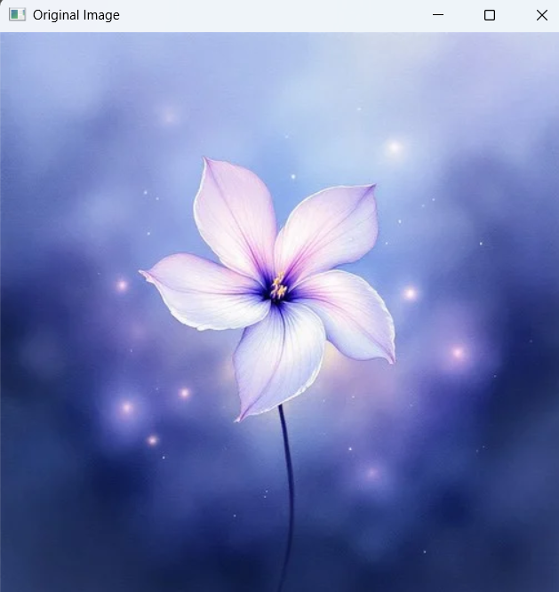
Input:

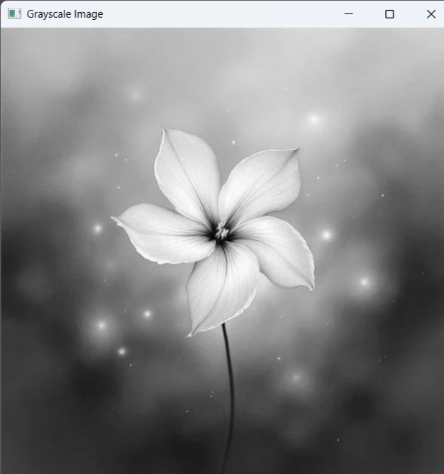

Output:

